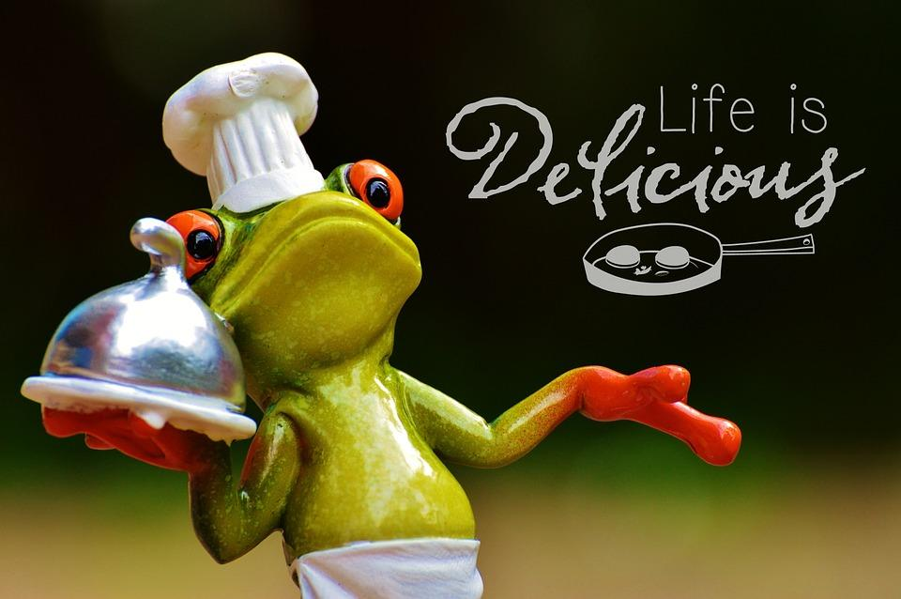

CULINARY ARTS II EXPLORATORY
Ms. Cowell
kcowell@hartdistrict.org
661-259-1551 ext. 1902
Website: https://cowellsculinaryarts.weebly.com/

Welcome to the Culinary Arts II Exploratory! This semester long exploratory will continue with food education and prep, meal planning, pastas and sauces, pastry, plating and catering, careers as well as some hot topics such as GMO’s, gluten free foods and food preservatives.

Please indicate on this form if your student has any type of food allergy and sign where indicated that you have read this informational letter.

Class Website
I have a class website that has numerous resources available to students such as class information, recipes, pictures and interesting culinary articles. The web address is listed above.

Laboratory Donations
In order for students to participate in as many cooking experiences as possible I am asking for a voluntary student donation of $25. This will allow students to engage in tastings that contribute to their learning and understanding of culinary arts. This is a very important source of funding for our food labs. Checks can be made out to Placerita Junior High (please include culinary arts and your student’s ID number in the memo area of the check). Cash is accepted as well. Attached is an envelope for your convenience.

Course Description
Students will gain experience and learn through a variety of units of study and labs. These units are designed in accordance with the California Career Technical Education Standards for the Hospitality, Tourism and Recreation Sector.

- Meal Planning and Budgeting
- Cooking Methods
- Baking Chemistry and Pastry
- Plating and Catering
- Pasta and Sauces
- Culinary Related Careers

This course will also focus on the basic life skills listed below:
- The ability to manage time and follow directions.
- Solve problems by processing available information and make decisions as appropriate.
- The ability to work with others to accomplish tasks/goals.
- Demonstrate essential knowledge of good work habits.
- Obtain, organize and evaluate information successfully.

Textbook and Supplies
We use a variety of textbooks and information that will be accessible through Google Classroom. Textbooks will be kept in the classroom. Students may borrow books to take home with permission from the teacher.

Attendance and Tardies
Attendance is important to your success in the classroom. If you are absent any worksheets and recipes are available in the back of the classroom in a file folder. It is your responsibility to ask a classmate or your teacher for work to make up from your absence. Unexcused tardies are unacceptable. You interrupt the class and distract others.

Class Papers and Handouts
Students are expected to keep all handouts and papers in a separate notebook or folder until the end of the quarter. We will refer to some of these materials throughout the year.

Homework
There is very little homework but when it is assigned you will have several days to complete it. Because of this, late work will have a score reduction of 20%. The same reduction applies to papers with no name once they are claimed from the ‘No Name Graveyard’ at the back of the classroom.

Grades
Grades are based on a point system:
- Classwork
- Lab Performance
- Quizzes
- Homework
Grading Scale (%)
A = 90% - 100% D = 60%- 69%
B = 80% - 89% F = 59% or below
C = 70% - 79%

All grades are weighted equally but most of your points will come from classwork and lab performance.

Lab requirements
Students must read the attached safety contract, sign the attached signature page as well as pass the safety test with a minimum of 90% in order to participate in the cooking labs. Students can retake the test until a passing score is achieved.

Students are required to wash their hands and tie back hair at the beginning of each class. Aprons are available for clothing protection as well. Closed toe shoes are required the day of the lab. Failure to do these things will result in a non-participation for the day.

Expectations for Students
Students are expected to follow the behavior standards of Placerita Junior High, as presented to you at registration. The following are additional standards I expect you to follow while in my classroom. Students who show repeated defiance of these rules may be removed from the program.
- Put your best effort into every task and let me know how I can help you succeed.
- Be a trustworthy citizen.
- Come to class on time and ready to learn.
- No headwear, sunglasses, or earphones or earbuds may be worn in my classroom.
- Personal electronic items, such as cell phones and iPods, cannot be used in class unless directed by the teacher.
- Be respectful of the kitchen, kitchen tools, and ingredients.
- Ask questions if you need extra help or do not understand something.
- No outside food, gum or drinks other than water are permitted in the classroom.

I look forward to a fun and exciting class!
Please sign the attached signature page verifying you have read and understand all of the information about this class.

Sincerely,

Karen Cowell

