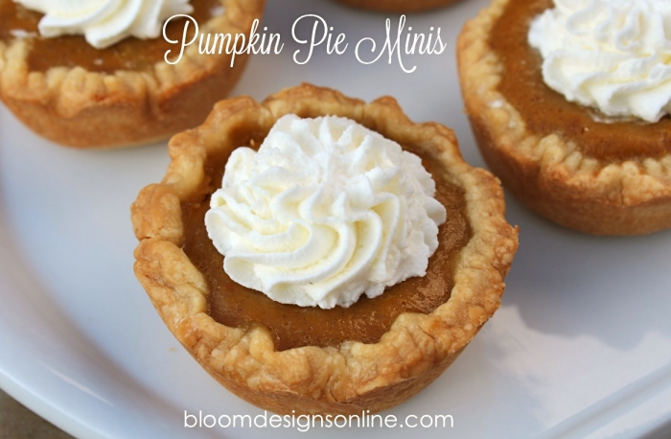
This recipe is for a regular sized cupcake/muffin pan. You can use any size muffin pan. Simply adjust the cooking time.
You Need
- 1 can pumpkin puree
- 1 cup brown sugar
- 1 cup cream
- 1/2 cup whole milk
- 2 eggs
- 1 teaspoon cinnamon
- 1/4 teaspoon salt
- 1/4 teaspoon ginger
- dash of clove
- dash of nutmeg
- 1 recipe for 2 pie crusts or 2 frozen pie crust thawed
Roll out your pie crust and cut into circles with a cookie cutter that is approximately 50% bigger than you muffin cavity. For a regular sized muffin pan, use a 3 inch cutter.
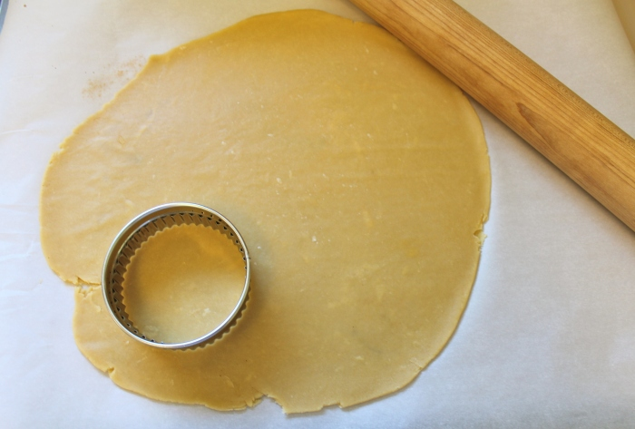
Gently take your pie circles and press them into the muffin pan. Flute the sides as you would for a standard pie.
In a large mixing bowl, mix remaining ingredients together. Fill crusts with pumpkin mixture until almost full.
Bake at 350 degrees for 25-30 minutes or until center of the custard is set.
Let cool and serve.

