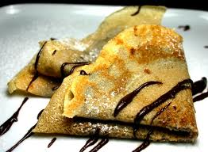
Nutella Banana Crepes

Time: 15 minutes

Crepes Ingredients:
- 1 cup of flour
- 2 eggs
- 1 1/2 cups of milk
- 1 tablespoon of raw or granulated sugar
- 1 tablespoon of butter, melted

Filling and Topping Ingredients:
- Nutella
- 2-3 bananas
- Powdered sugar

Directions:
- Mix together milk, melted butter and eggs until well blended.
- Blend in sugar.
- Slowly mix in flour until well blended.
- Slowly pour approximately 1/4 cup into a heated skillet or griddle. Crepes are meant to be thin, be sure to not oversize it so it is still easy to flip.
- Cook on each side for approx 30 seconds.
- Fill each crepe with Nutella by spreading it on half of the crepe, then add sliced bananas and fold over.
- Heat a few tablespoons of Nutella in the microwave on approximately 35 seconds so it is easy to garnish on the top.
- Take a spoon and fill with heated Nutella, spreading in lines across the top of the crepe.
- Finish with sprinkled powdered sugar, enjoy!

